EVENTS:
GUI Component an object that represents a screen element like button, text field , slider or menu. Frames and panels are components and are also containers that can hole components.

GUI components generate events. Aprogram designed around this is event driven.

Listners wait for events. When an event occurs a gui component create an event object and passes it to the appropriate listner.

Gui component
event listner
1.register listner
2. event

To create a java program that uses a gui
1 create and setup the necessary components
2. implement the listener classes and what happens when events occur
3. establish the relationship between listeners and components

Packages java.awt
And the newer javax.swing

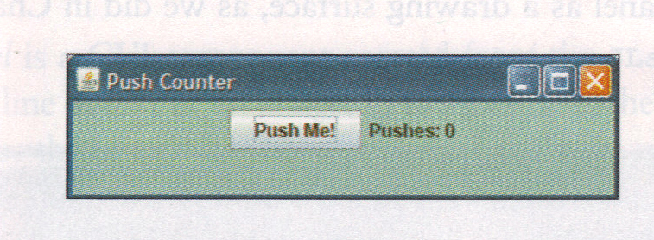

Eg
Pushcounter.java // driver program
Pushcounterpanel.java //
Buttonlistner.java

//*****************************************************************************
// PushCounter.java Programming with Alice and Java
//
// Demonstrates a graphical user interface and an event listener.
//*****************************************************************************

import javax.swing.JFrame;

public class PushCounter
{
//--------------------------------------------------------------------------
// Creates and displays the main program frame.
//--------------------------------------------------------------------------
public static void main(String[] args)
{
JFrame frame = new JFrame("Push Counter");

PushCounterPanel panel = new PushCounterPanel();

frame.getContentPane().add(panel);
frame.setDefaultCloseOperation(JFrame.EXIT_ON_CLOSE);
frame.pack();
frame.setVisible(true);
}
}

Note PushCounter
- Import Jframe
- Create the frame.
- Create the panel object
- Add the panel to the frame
- Exit on close
- Pack
- setvisible

//*****************************************************************************
// PushCounterPanel.java Programming with Alice and Java
//
// Represents the main panel for the PushCounter program, containing a
// button and a label displaying how many times the button was pushed.
//*****************************************************************************

import java.awt.*;
import javax.swing.*;
import java.awt.event.*;

public class PushCounterPanel extends JPanel
{
private int count;
private JLabel label;
private JButton push;

//--------------------------------------------------------------------------
// Sets up the interface on the panel.
//--------------------------------------------------------------------------
public PushCounterPanel()
{
count = 0;

label = new JLabel("Pushes: " + count);
push = new JButton("Push Me!");

ButtonListener listener = new ButtonListener(this);
push.addActionListener(listener);

add(push);
add(label);

setBackground (Color.cyan);
setPreferredSize (new Dimension(350, 60));
}

//--------------------------------------------------------------------------
// Increments the counter and updates the label accordingly.
//--------------------------------------------------------------------------
public void incrementCount()
{
count++;
label.setText("Pushes: " + count);
}
}

PushcounterPanel
- import ???
- extend ?
- methods/constructors 1____ 2_______
- elements Jlabel JButton
- listener ButonListener
- link JButton (push) to listener
- add push and label to panel
- set background and size

//*****************************************************************************
// ButtonListener.java Programming with Alice and Java
//
// Represents the push button listener for the PushCounter program.
//*****************************************************************************

import java.awt.event.*;

public class ButtonListener implements ActionListener
{
private PushCounterPanel panel;

//--------------------------------------------------------------------------
// Stores the panel in order to update the counter.
//--------------------------------------------------------------------------
public ButtonListener(PushCounterPanel pushPanel)
{
panel = pushPanel;
}

//--------------------------------------------------------------------------
// Updates the counter and label when the button is pushed.
//--------------------------------------------------------------------------
public void actionPerformed(ActionEvent event)
{
panel.incrementCount();
}
}

ButtonListener
- implements ?
- methods?
- constructor takes the pushPanel object.
- Actionperformed has actionevent object (does nothing with it) and just calls pushcounterpanel object method.

Pushcounter panel has two components added to it a button and a label.
Label is a Jlabel. For displaying the count.
Button is an action for the user pressing the mouse. It’s a Jbutton and generates an event. So we need an event listener.

Buttonlistner implement the actionlistner interface. It must implement all the methods of the interface. Only one method actionperformed.

The event object (we do nothing to it here) just incrementcount.

Addactionlistner set up the relationship between buttonlistner and the button.

Event types:
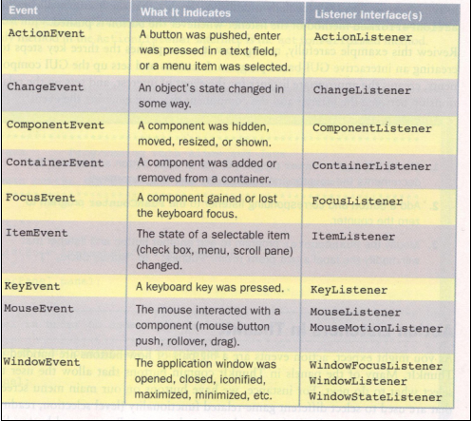

Snowman program:

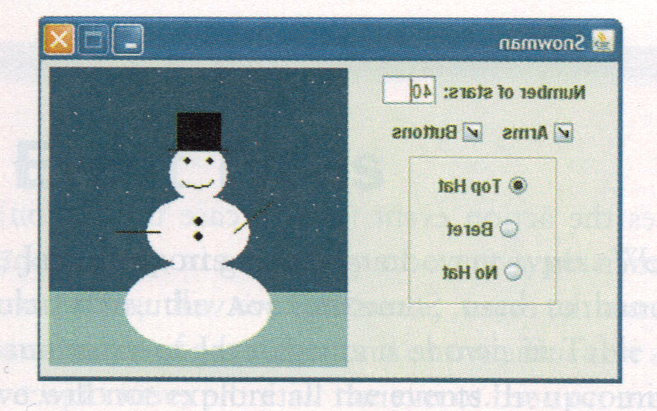
Snowmanpanel.java
//*****************************************************************************
// SnowmanPanel.java Programming with Alice and Java
//
// Represents the main panel for the Snowman program. Uses inner classes
// for the listeners.
//*****************************************************************************

import java.awt.*;
import javax.swing.*;
import java.awt.event.*;

public class SnowmanPanel extends JPanel
{
private JCheckBox armsCheckBox, buttonsCheckBox;
private JTextField starsField;
private JRadioButton topHat, beret, noHat;
private SnowmanDrawPanel drawPanel;

//--------------------------------------------------------------------------
// Sets up the interface of the control panel.
//--------------------------------------------------------------------------
public SnowmanPanel()
{
drawPanel = new SnowmanDrawPanel();
// 1. create the components 2. addlistners

JLabel starsLabel = new JLabel("Number of stars:");
starsField = new JTextField(3);
starsField.setText(Integer.toString(drawPanel.DEFAULT_STARS));
starsField.addActionListener(new StarsListener());

armsCheckBox = new JCheckBox("Arms");
buttonsCheckBox = new JCheckBox("Buttons");
CheckBoxListener checkBoxListener = new CheckBoxListener();
armsCheckBox.addItemListener(checkBoxListener);
buttonsCheckBox.addItemListener(checkBoxListener);

topHat = new JRadioButton("Top Hat", true);
beret = new JRadioButton("Beret", false);
noHat = new JRadioButton("No Hat", false);

RadioButtonListener radioButtonListener = new RadioButtonListener();
topHat.addActionListener(radioButtonListener);
beret.addActionListener(radioButtonListener);
noHat.addActionListener(radioButtonListener);
ButtonGroup hatGroup = new ButtonGroup();
hatGroup.add(topHat);
hatGroup.add(beret);
hatGroup.add(noHat);
// create the hatpanel like a subpannel
JPanel hatPanel = new JPanel();
hatPanel.setPreferredSize(new Dimension(100, 100));
hatPanel.setBorder(BorderFactory.createEtchedBorder());
hatPanel.add(topHat);
hatPanel.add(beret);
hatPanel.add(noHat);
// controlpanel the left of the screen and add the elements to it
JPanel controlPanel = new JPanel();
controlPanel.add(starsLabel);
controlPanel.add(starsField);
controlPanel.add(armsCheckBox);
controlPanel.add(buttonsCheckBox);
controlPanel.add(hatPanel);
controlPanel.setPreferredSize(new Dimension(170, 200));
// add the controlpanel and the snowman drawing draw panel
add(controlPanel);
add(drawPanel);
}

//**************************************************************************
// The listener for the text field that determines the number of stars.
//**************************************************************************
private class StarsListener implements ActionListener
{
public void actionPerformed(ActionEvent event)
{
drawPanel.setNumStars(Integer.parseInt(starsField.getText()));
drawPanel.repaint();
}
}

//**************************************************************************
// The listener for both check boxes that determine whether the arms and
// buttons are drawn.
//**************************************************************************
private class CheckBoxListener implements ItemListener
{
public void itemStateChanged(ItemEvent event)
{
drawPanel.setArms(armsCheckBox.isSelected());
drawPanel.setButtons(buttonsCheckBox.isSelected());
drawPanel.repaint();
}
}

//**************************************************************************
// The listener for the radio buttons that determine the hat style.
//**************************************************************************
private class RadioButtonListener implements ActionListener
{
public void actionPerformed(ActionEvent event)
{
Object source = event.getSource();

if (source == topHat)
drawPanel.setHat("top hat");
else
if (source == beret)
drawPanel.setHat("beret");
else
drawPanel.setHat("no hat");

drawPanel.repaint();
}
}

}

Inner classes listners.

Snowmandrawpanel.java
//*****************************************************************************
// SnowmanDrawPanel.java Programming with Alice and Java
//
// Represents the drawing panel for the Snowman program.
//*****************************************************************************

import java.awt.*;
import javax.swing.*;
import java.awt.event.*;
import java.util.Random;

public class SnowmanDrawPanel extends JPanel
{
public final int DEFAULT_STARS = 40;

private int numStars;
private boolean arms, buttons;
private String hat;
private Random rand;

//--------------------------------------------------------------------------
// Sets up the default status of the drawing panel.
//--------------------------------------------------------------------------
public SnowmanDrawPanel()
{
numStars = DEFAULT_STARS;
arms = false;
buttons = false;
hat = "top hat";

rand = new Random();

setBackground(Color.blue);
setPreferredSize(new Dimension(200, 200));
}

//--------------------------------------------------------------------------
// Paints the snowman on this panel.
//--------------------------------------------------------------------------
public void paintComponent(Graphics gc)
{
super.paintComponent(gc);

final int MID = 100, TOP = 50;

gc.setColor(Color.cyan);
gc.fillRect(0, 150, 200, 50); // ground

gc.setColor(Color.white);
for (int count=1; count <= numStars; count++)
gc.fillOval(rand.nextInt(190), rand.nextInt(140), 1, 1); // stars

gc.fillOval(MID-20, TOP, 40, 40); // head
gc.fillOval(MID-35, TOP+35, 70, 50); // upper torso
gc.fillOval(MID-50, TOP+80, 100, 60); // lower torso

gc.setColor(Color.black);
gc.fillOval(MID-10, TOP+10, 5, 5); // left eye
gc.fillOval(MID+5, TOP+10, 5, 5); // right eye
gc.drawArc(MID-10, TOP+20, 20, 10, 190, 160); // smile

if (arms)
{
gc.drawLine(MID-25, TOP+60, MID-50, TOP+40); // left arm
gc.drawLine(MID+25, TOP+60, MID+55, TOP+60); // right arm
}

if (buttons)
{
gc.fillOval(MID-3, TOP+50, 6, 6); // button
gc.fillOval(MID-3, TOP+60, 6, 6); // button
}

if (hat.equals("top hat"))
{
gc.drawLine(MID-20, TOP+5, MID+20, TOP+5); // brim of hat
gc.fillRect(MID-15, TOP-20, 30, 25); // top of hat
}
else
if (hat.equals("beret"))
{
gc.setColor(Color.red);
gc.fillOval(MID-15, TOP-3, 30, 10);
}

}

//--------------------------------------------------------------------------
// Sets the value that determines if the arms are drawn.
//--------------------------------------------------------------------------
public void setArms(boolean status)
{
arms = status;
}

//--------------------------------------------------------------------------
// Sets the value that determines if the buttons are drawn.
//--------------------------------------------------------------------------
public void setButtons(boolean status)
{
buttons = status;
}

//--------------------------------------------------------------------------
// Sets the value that determines the number of stars that are drawn.
//--------------------------------------------------------------------------
public void setNumStars(int count)
{
numStars = count;
}

//--------------------------------------------------------------------------
// Sets the value that determines the style of hat, if any, that is drawn.
//--------------------------------------------------------------------------
public void setHat(String currentHat)
{
hat = currentHat;
}
}

//*****************************************************************************
// Snowman.java Programming with Alice and Java
//
// Demonstrates more GUI components and event listeners.
//*****************************************************************************

import javax.swing.JFrame;

public class Snowman
{
//--------------------------------------------------------------------------
// Creates and displays the main program frame.
//--------------------------------------------------------------------------
public static void main(String[] args)
{
JFrame frame = new JFrame("Snowman");

frame.getContentPane().add(new SnowmanPanel());
frame.setDefaultCloseOperation(JFrame.EXIT_ON_CLOSE);
frame.pack();
frame.setResizable(false);
frame.setVisible(true);
}
}

Three classes
- SnowMan : as before
- SnowManPanel extends JPanel, inner classes action and item listeners.
- SnowmanDrawPanel also extends JPanel and has a paintcomponent the snowman, plus methods to set characteristics of the drawing.

Players:
starsfield starslistner
Armscheckbox buttoncheckbox share checkboxlistener

Tophat beret nohat share radiobuttonlistener.

Hatpanel is used to improve the display.

Snowmandrawpanel: paintcomponent does the drawing. Constructor set initial default values.

Mouse events
Button pressed
Button released
Clicked and released at the same location
Cursor entered a component (moved over)
Cursor exited a component (moved off)

Mouse moved
Mouse dragged

Two listener interfaces: Mouselistner used for the first five above. And MouseMotionlistener for moved or dragged events.

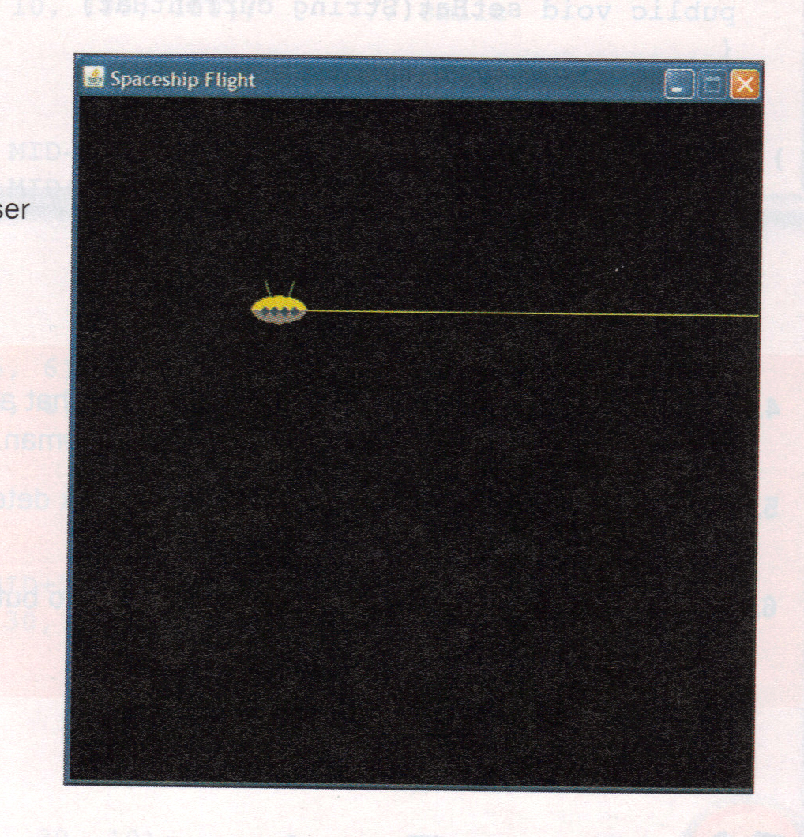

Space ship flight moves with the mouse and fires laser on mouse press.

Driver simple

SpaceshipPanel.java (has a paintcomponent) and Spaceshiplistener as an inner class.
Make a ship.
Make a listener (monitor).
Associate the listener with the mouse actions.
Set a few things.
Spaceshiplistener implements the interfaces mousemotionlistener and mouselistener.
Dragged or moved or pressed or released. Other methods unused i.e.No clicked entered or exited.

Spaceship.java has a draw method that takes a Graphics object as a parameter got from paintcomponent, and draws the image. It also has setshooting and setlocation.

Spaceship.java
Set loation
Setshooting

Draw
//*****************************************************************************
// Spaceship.java Programming with Alice and Java
//
// Represents a space ship drawn in some graphics context. Maintains the
// ship's location and whether or not the ship is shooting a laser beam.
//*****************************************************************************

import java.awt.*;

public class Spaceship
{
private int x, y;
private boolean shooting;
private final int WIDTH = 40, HEIGHT = 20;

//--------------------------------------------------------------------------
// Sets the ships location.
//--------------------------------------------------------------------------
public void setLocation(int xPos, int yPos)
{
x = xPos;
y = yPos;
}

//--------------------------------------------------------------------------
// Sets the shooting mode of the ship.
//--------------------------------------------------------------------------
public void setShooting(boolean value)
{
shooting = value;
}

//--------------------------------------------------------------------------
// Draws the ship in the specified graphics context.
//--------------------------------------------------------------------------
public void draw(Graphics gc, int screenWidth)
{
int baseX = x - WIDTH;
int baseY = y - HEIGHT/2;

// antennae
gc.setColor(Color.green);
gc.drawLine(baseX + 10, baseY-10, baseX + WIDTH/2, y + HEIGHT/2);
gc.drawLine(baseX + WIDTH/2, y + HEIGHT/2, x - 10, baseY-10);

// body
gc.setColor(Color.orange);
gc.fillArc(baseX, baseY, WIDTH, HEIGHT, 0, 180);
gc.setColor(Color.magenta);
gc.fillArc(baseX, baseY, WIDTH, HEIGHT, 0, -180);

// windows
gc.setColor(Color.blue);
for (int i=0; i < 4; i++)
gc.fillOval(baseX+(i+1)*7, baseY+8, 6, 6);

// laser
if (shooting)
{
gc.setColor(Color.yellow);
gc.drawLine(x, y, screenWidth, y);
}
}
}

//*****************************************************************************
// SpaceshipPanel.java Programming with Alice and Java
//
// Represents the panel on which the spaceship is drawn. Generates mouse
// events that controls the flight and behavior.
//*****************************************************************************

import java.awt.*;
import javax.swing.*;
import java.awt.event.*;

public class SpaceshipPanel extends JPanel
{
private Spaceship ship;

//--------------------------------------------------------------------------
// Sets up the panel. Uses one listener for mouse and mouse motion events.
//--------------------------------------------------------------------------
public SpaceshipPanel()
{
ship = new Spaceship();

SpaceshipListener monitor = new SpaceshipListener();
addMouseMotionListener(monitor);
addMouseListener(monitor);

setCursor(Cursor.getPredefinedCursor(Cursor.CROSSHAIR_CURSOR));
setBackground (Color.black);
setPreferredSize(new Dimension(480, 480));
}

//--------------------------------------------------------------------------
// Draws the spaceship.
//--------------------------------------------------------------------------
public void paintComponent(Graphics gc)
{
super.paintComponent(gc);
ship.draw(gc, getWidth());
}

//**************************************************************************
// The listener for all mouse events.
//**************************************************************************
private class SpaceshipListener implements MouseListener, MouseMotionListener
{
//-----------------------------------------------------------------------
// Changes the ships location as the mouse moves.
//-----------------------------------------------------------------------
public void mouseMoved(MouseEvent event)
{
ship.setLocation(event.getX(), event.getY());
repaint();
}

//-----------------------------------------------------------------------
// Changes the ships location as the mouse is dragged.
//-----------------------------------------------------------------------
public void mouseDragged(MouseEvent event)
{
ship.setLocation(event.getX(), event.getY());
repaint();
}

//-----------------------------------------------------------------------
// Puts the ship in "shooting" mode when the mouse button is pressed.
//-----------------------------------------------------------------------
public void mousePressed(MouseEvent event)
{
ship.setShooting(true);
repaint();
}

//-----------------------------------------------------------------------
// Stops the ship from shooting when the mouse button is released.
//-----------------------------------------------------------------------
public void mouseReleased(MouseEvent event)
{
ship.setShooting(false);
repaint();
}

//--------------------------------------------------------------------------
// Empty definitions for unused events.
//--------------------------------------------------------------------------
public void mouseClicked(MouseEvent event) {}
public void mouseEntered(MouseEvent event) {}
public void mouseExited(MouseEvent event) {}
}
}

//*****************************************************************************
// SpaceshipFlight.java Programming with Alice and Java
//
// Demonstrates the use of mouse events.
//*****************************************************************************

import javax.swing.*;

public class SpaceshipFlight
{
//--------------------------------------------------------------------------
// Creates and displays the main program frame.
//--------------------------------------------------------------------------
public static void main(String[] args)
{
JFrame frame = new JFrame("Spaceship Flight");

frame.getContentPane().add(new SpaceshipPanel());
frame.setDefaultCloseOperation(JFrame.EXIT_ON_CLOSE);
frame.pack();
frame.setResizable(false);
frame.setVisible(true);
}
}

Keyboard events:
A keyboard event occurs when a key is pressed you do not wait for return to be pressed as in text field or dos box.

Set up a listener to respond to any key being pressed. Then identify the key and respond to the value.

Program when the user presses 1,2,3 the appropriate image is displayed. Spacebar/other display an image at random.

Driver imageflicker.java
The panel is imageflickerpanel.java // keyboardlistener as inner class.
Keylistener interface has three methods. Keypressed, keyreleased and keytyped(character produced).
Keytyped handles repetition ie key held down.

In imageflicker only keypressed event is implemented.

Getkeychar method is used to get the character. Getkeycode could also be used for arrow /function keys non chars.

Setfocusable sets the current keyboard focus to the displayed panel generally click the panel to be sure.

//*****************************************************************************
// ImageFlicker.java Programming with Alice and Java
//
// Demonstrates the use of key events.
//*****************************************************************************

import javax.swing.*;

public class ImageFlicker
{
//--------------------------------------------------------------------------
// Creates and displays the main program frame.
//--------------------------------------------------------------------------
public static void main(String[] args)
{
JFrame frame = new JFrame("Image Flicker");

frame.getContentPane().add(new ImageFlickerPanel());
frame.setDefaultCloseOperation(JFrame.EXIT_ON_CLOSE);
frame.pack();
frame.setResizable(false);
frame.setVisible(true);
}
}

//*****************************************************************************
// ImageFlickerPanel.java Programming with Alice and Java
//
// Represents the display panel for the ImageFlicker program.
//*****************************************************************************

import java.awt.*;
import java.util.*;
import javax.swing.*;
import java.awt.event.*;

public class ImageFlickerPanel extends JPanel
{
private Image image1, image2, image3;
private Image currentImage;
private Random rand;

//--------------------------------------------------------------------------
// Loads the images and sets the panel characteristics.
//--------------------------------------------------------------------------
public ImageFlickerPanel()
{
addKeyListener(new KeyboardListener());

image1 = (new ImageIcon("babyFace.jpg")).getImage();
image2 = (new ImageIcon("closeUp.jpg")).getImage();
image3 = (new ImageIcon("twoBoys.jpg")).getImage();
currentImage = image1;

rand = new Random();

setBackground(Color.black);
setPreferredSize(new Dimension(500, 375));
setFocusable(true);
}

//--------------------------------------------------------------------------
// Draws the image on the panel.
//--------------------------------------------------------------------------
public void paintComponent(Graphics gc)
{
super.paintComponent(gc);
gc.drawImage(currentImage, 0, 0, null);
}

//**************************************************************************
// The listener for keyboard presses.
//**************************************************************************
private class KeyboardListener implements KeyListener
{
//-----------------------------------------------------------------------
// Switches the current image based on the key pressed.
//-----------------------------------------------------------------------
public void keyPressed(KeyEvent event)
{
switch (event.getKeyChar())
{
case '1':
currentImage = image1;
break;

case '2':
currentImage = image2;
break;

case '3':
currentImage = image3;
break;

case ' ':
switch (rand.nextInt(3))
{
case 0:
currentImage = image1;
break;
case 1:
currentImage = image2;
break;
case 2:
currentImage = image3;
}
}
repaint();
}

//-----------------------------------------------------------------------
// Empty definitions for unused events.
//-----------------------------------------------------------------------
public void keyReleased(KeyEvent event) { }
public void keyTyped(KeyEvent event) { }
}
}

Excerises:
1.Add the feature to guess a location for a big green snowball to fire at the snowman (2 ltextfields).
2.Use the mouse to fire a snowball at the snowman (you cant miss)
3.Exercise Implement a traffic light use mouse click to turn lights on/off .
4.Try to spawn a new frame and make the user close it.

